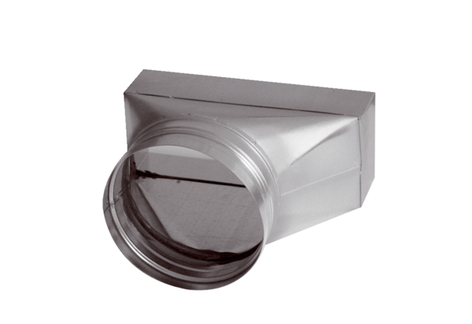Intermediate piece, asymmetric USAN80/150/80Packing unit: 1 pieceRange: K
Article number: 0055.0667Manufacturer: MAICO

