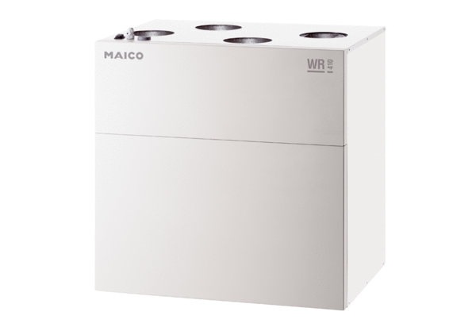Centralised ventilation unit WR 600Packing unit: 1 pieceRange: K
Article number: 0095.0080Manufacturer: MAICO

