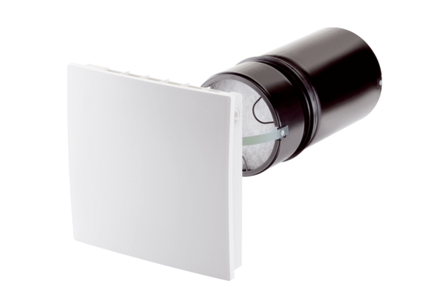Final assembly kit PP 45 KPacking unit: 1 pieceRange: K
Article number: 0095.0241Manufacturer: MAICO

