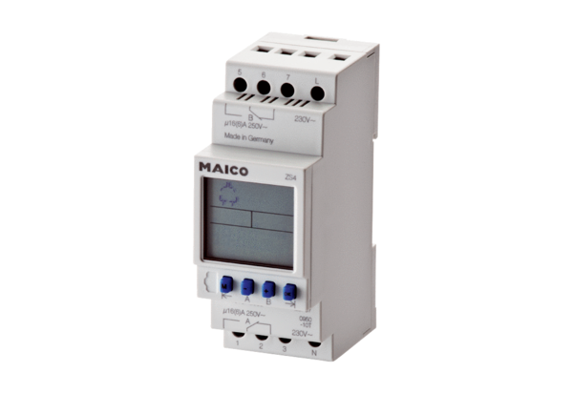Timer ZS 4Packing unit: 1 pieceRange: A
Article number: 0157.0088Manufacturer: MAICO

