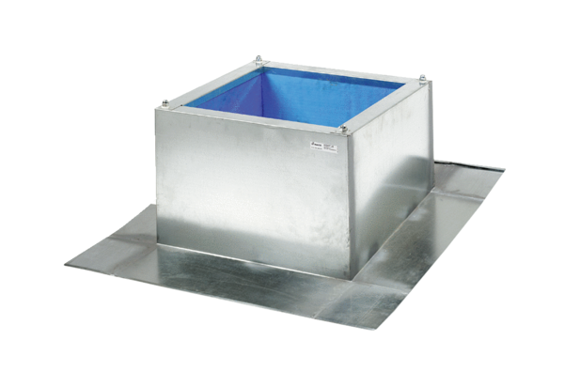Roof socket for corrugated and trapezoidal roofs SOWT 22Packing unit: 1 pieceRange: C
Article number: 0093.0984Manufacturer: MAICO

