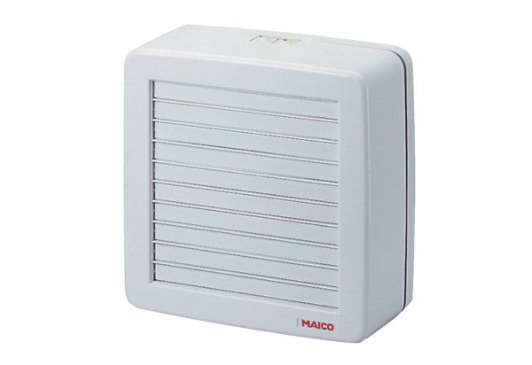Axial window fan EVH 31Packing unit: 1 pieceRange: C
Article number: 0080.0822Manufacturer: MAICO

