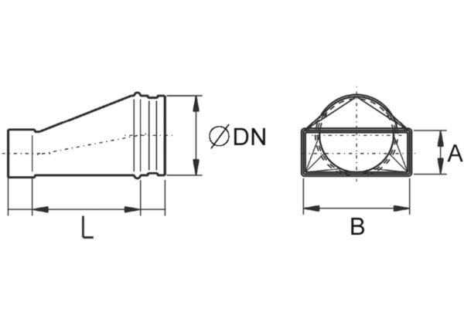Intermediate piece, asymmetric USAN55/220/125Packing unit: 1 pieceRange: K
Article number: 0055.0661Manufacturer: MAICO

