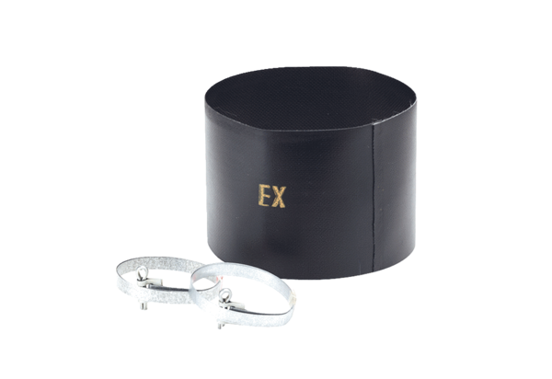Flexible cuff ELM 14 ExPacking unit: 1 pieceRange: C
Article number: 0092.0246Manufacturer: MAICO

