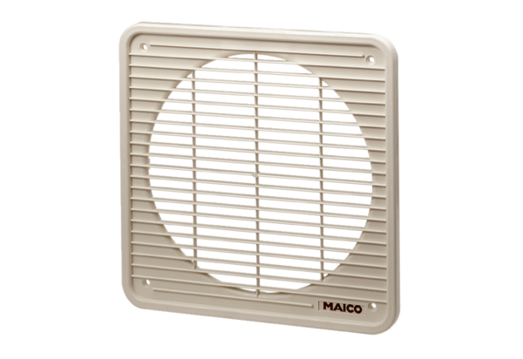Internal grille IG 45/50Packing unit: 1 pieceRange: C
Article number: 0059.0176Manufacturer: MAICO

