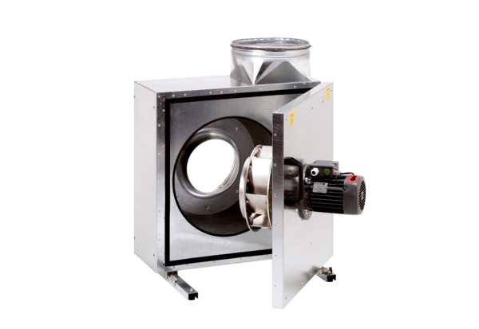Sound-insulated ventilation box EKR 35-2Packing unit: 1 pieceRange: C
Article number: 0080.0885Manufacturer: MAICO

