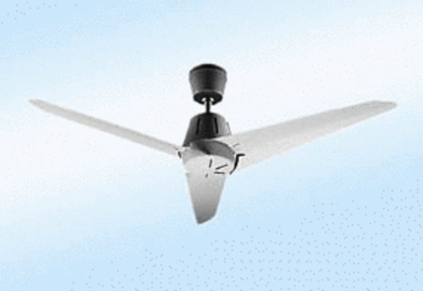Axial ceiling fan EC 140 APacking unit: 1 pieceRange: C
Article number: 0088.0175Manufacturer: MAICO

