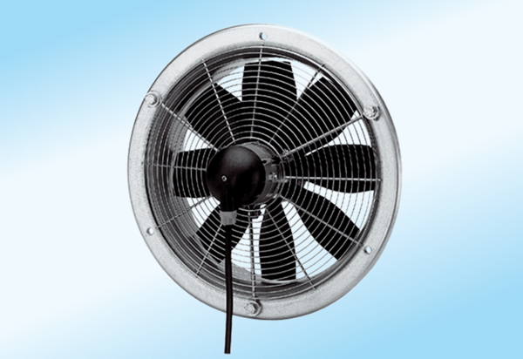Axial wall fan DZS 35/4 A-ExPacking unit: 1 pieceRange: C
Article number: 0094.0109Manufacturer: MAICO

