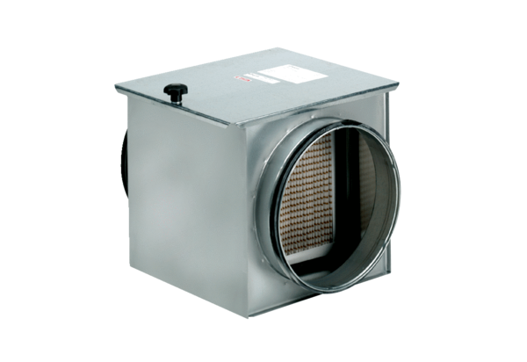Air filter TFE 20-7Packing unit: 1 pieceRange: C
Article number: 0149.0053Manufacturer: MAICO

