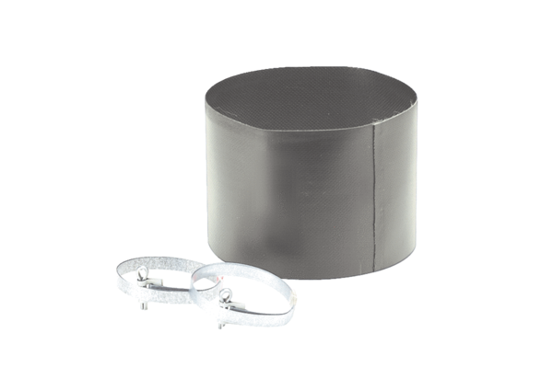Flexible cuff ELM 25Packing unit: 1 pieceRange: C
Article number: 0092.0119Manufacturer: MAICO

