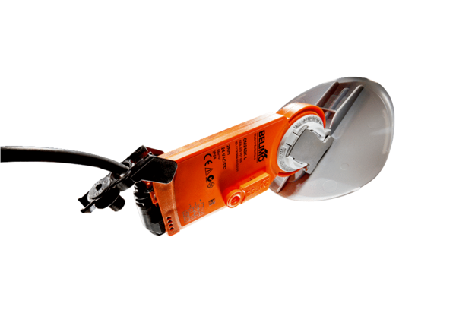Shutter drive with air damper MS 160 SPacking unit: 1 pieceRange: C
Article number: 0157.1238Manufacturer: MAICO

