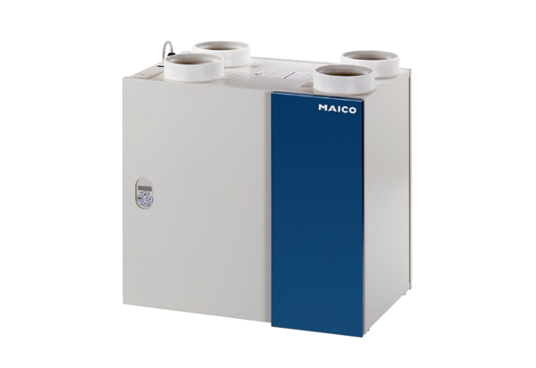Aeronom room air system WRG 300 ECPacking unit: 1 pieceRange: K
Article number: 0082.0060Manufacturer: MAICO

