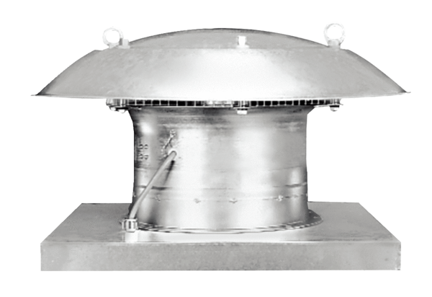Axial roof fan DZD 50/4 BPacking unit: 1 pieceRange: C
Article number: 0087.0226Manufacturer: MAICO

