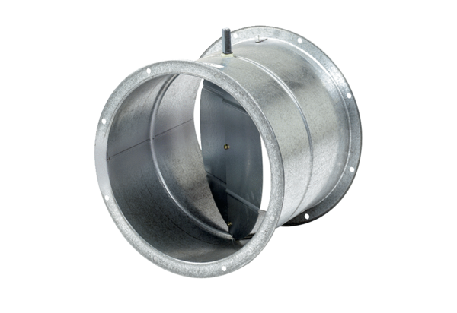Shutter, servomotor VE 40Packing unit: 1 pieceRange: C
Article number: 0093.0288Manufacturer: MAICO

