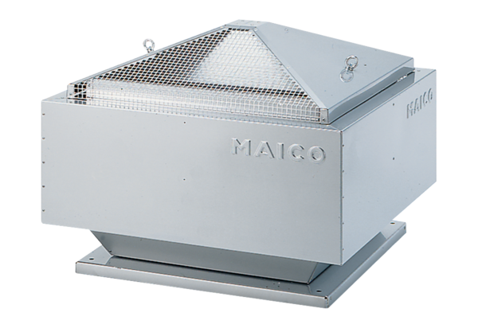Centrifugal roof fan ERD 31/6 BPacking unit: 1 pieceRange: C
Article number: 0087.0005Manufacturer: MAICO

