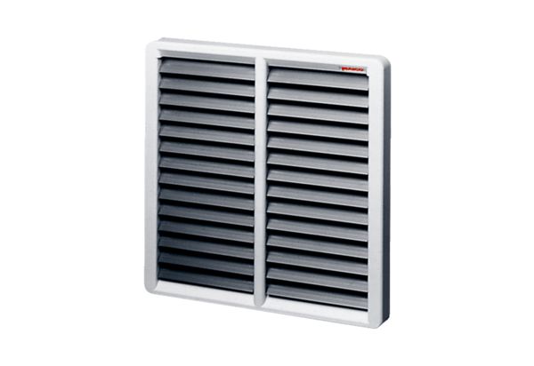Shutter, manual RS 35Packing unit: 1 pieceRange: C
Article number: 0151.0341Manufacturer: MAICO

