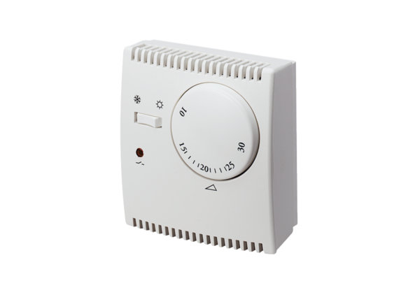Thermostat THR 10Packing unit: 1 pieceRange: C
Article number: 0157.0774Manufacturer: MAICO

