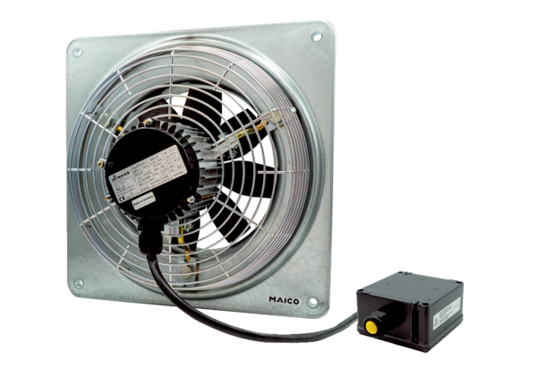Axial wall fan DZQ 45/4 B Ex ePacking unit: 1 pieceRange: C
Article number: 0083.0183Manufacturer: MAICO

