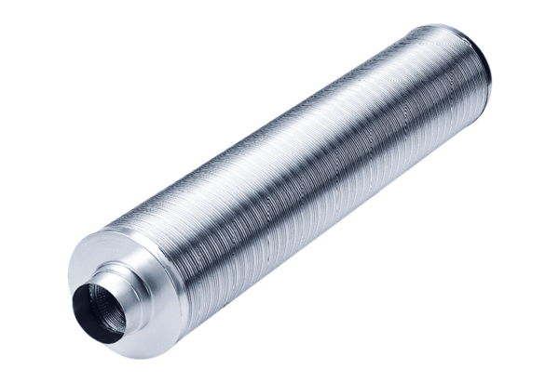Tubular sound absorber RSR 15/50Packing unit: 1 pieceRange: C
Article number: 0092.0323Manufacturer: MAICO

