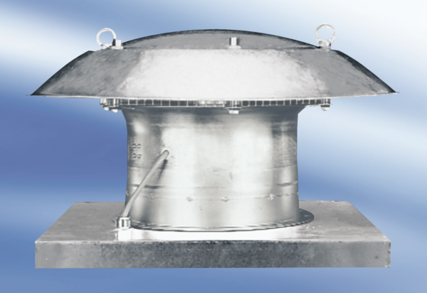Axial roof fan DZD 60/8 APacking unit: 1 pieceRange:
Article number: 0087.0427Manufacturer: MAICO

