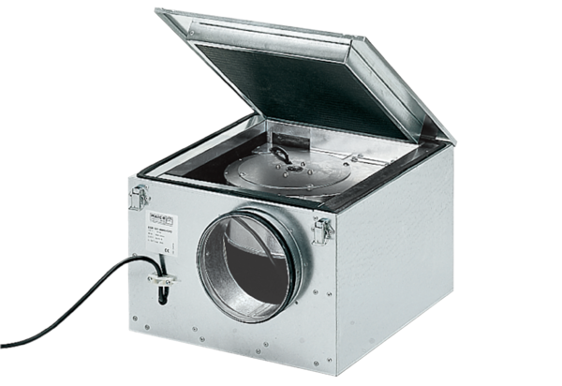Sound-insulated ventilation box ESR 35/1Packing unit: 1 pieceRange: C
Article number: 0080.0286Manufacturer: MAICO

