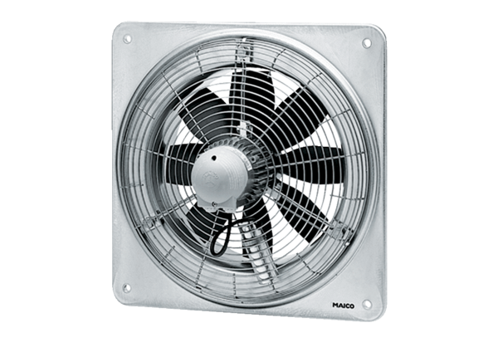Axial wall fan EZQ 30/4 BPacking unit: 1 pieceRange: C
Article number: 0083.0106Manufacturer: MAICO

