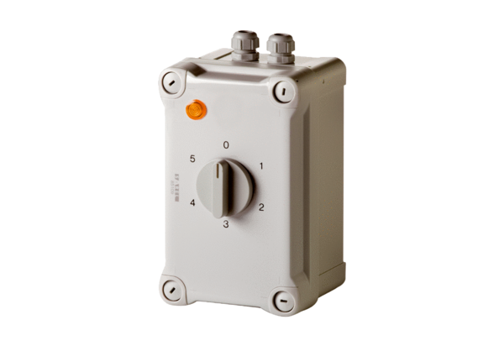5-step transformer TRE 1,6-1Packing unit: 1 pieceRange: C
Article number: 0157.0348Manufacturer: MAICO

