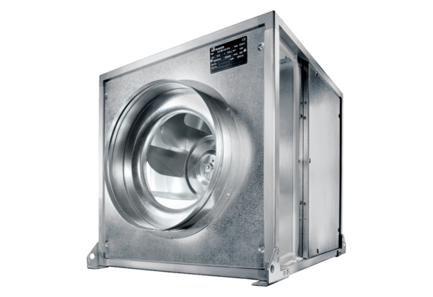Quickbox DSQ 35/4 KPacking unit: 1 pieceRange: C
Article number: 0080.0076Manufacturer: MAICO

