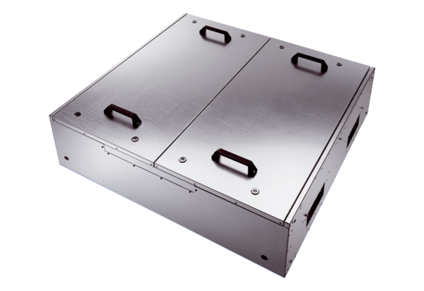Sound-insulated ventilation box KFD 9030-KPacking unit: 1 pieceRange: K
Article number: 0080.0968Manufacturer: MAICO

