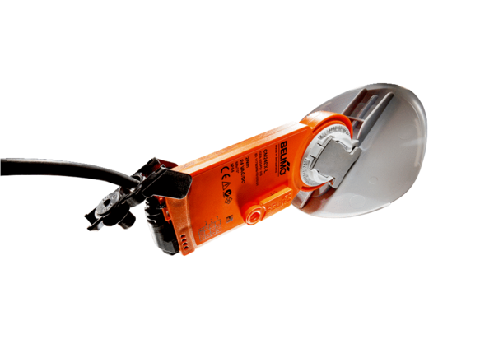Shutter drive with air damper MS 100Packing unit: 1 pieceRange: C
Article number: 0157.1231Manufacturer: MAICO

