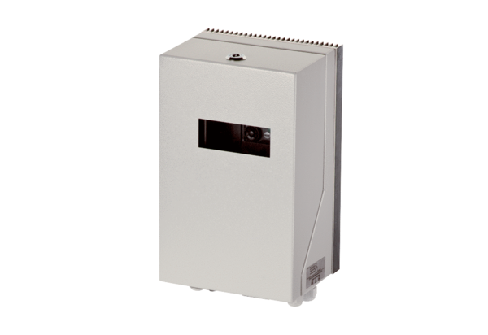Frequency converter MFU 1Packing unit: 1 pieceRange: C
Article number: 0157.1214Manufacturer: MAICO

