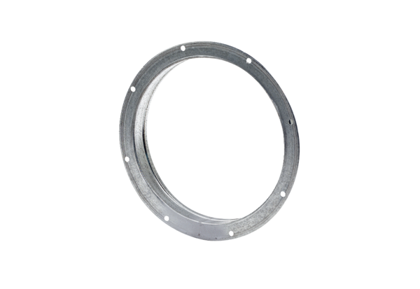Counter socket GS 40Packing unit: 1 pieceRange: C
Article number: 0055.0172Manufacturer: MAICO

