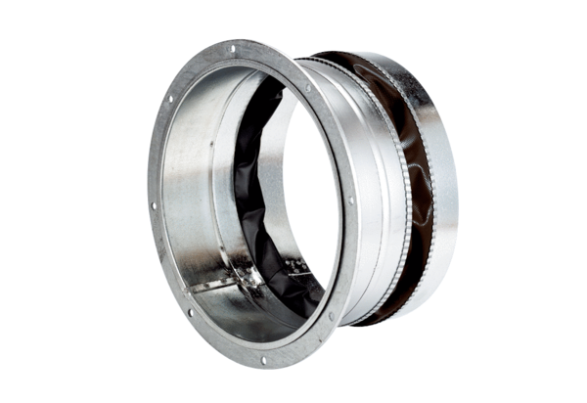Flexible coupling ELA 50 ExPacking unit: 1 pieceRange: C
Article number: 0092.0280Manufacturer: MAICO

