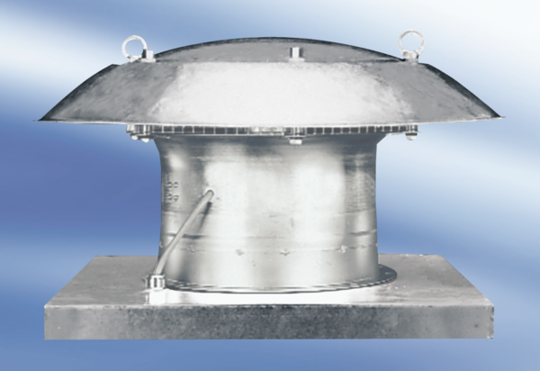Axial roof fan EZD 35/6 APacking unit: 1 pieceRange:
Article number: 0087.0406Manufacturer: MAICO

