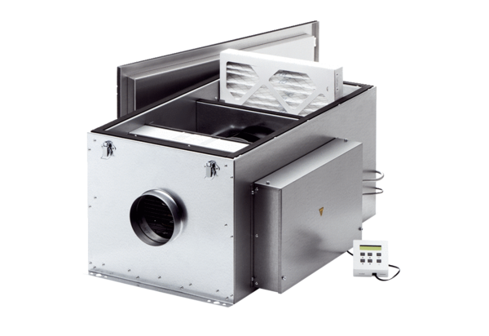Compact box ECR 31 ECPacking unit: 1 pieceRange: E
Article number: 0080.0578Manufacturer: MAICO

