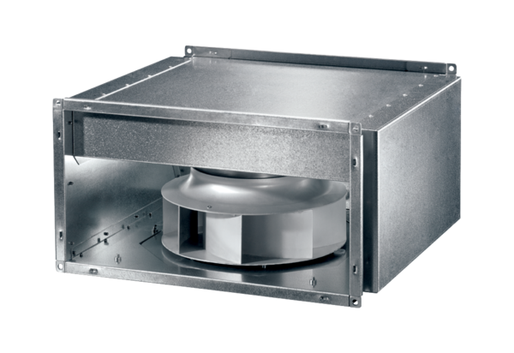Sound-insulated channel fan DSK 31 ECPacking unit: 1 pieceRange: E
Article number: 0086.0803Manufacturer: MAICO

