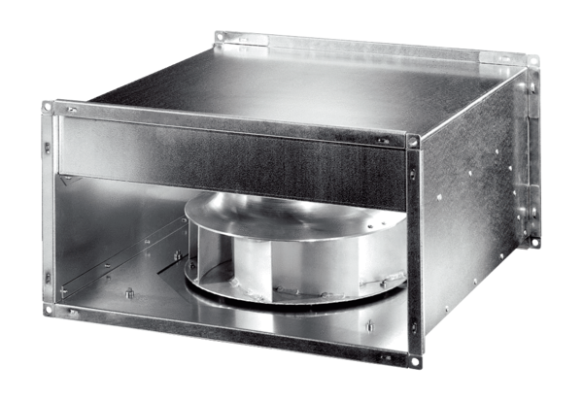Channel fan DPK 31-S ECPacking unit: 1 pieceRange: E
Article number: 0086.0804Manufacturer: MAICO

