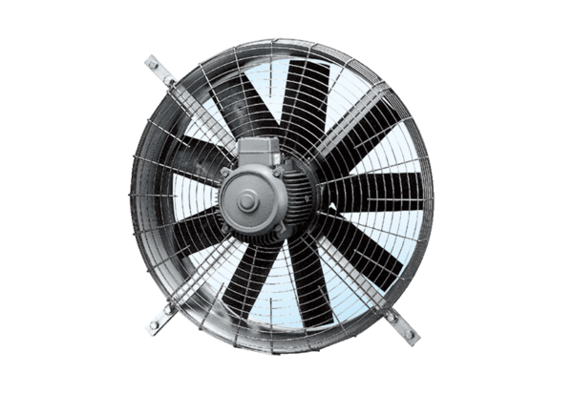Axial wall fan DZQ 100/12Packing unit: 1 pieceRange: C
Article number: 0083.0646Manufacturer: MAICO

