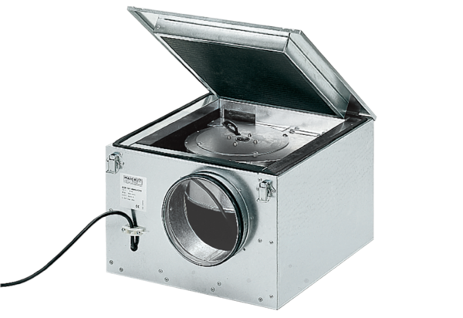Sound-insulated ventilation box ESR 20/1Packing unit: 1 pieceRange: C
Article number: 0080.0283Manufacturer: MAICO

