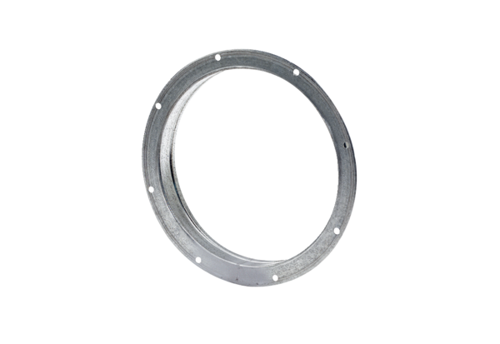Counter socket GS 50Packing unit: 1 pieceRange: C
Article number: 0055.0174Manufacturer: MAICO

