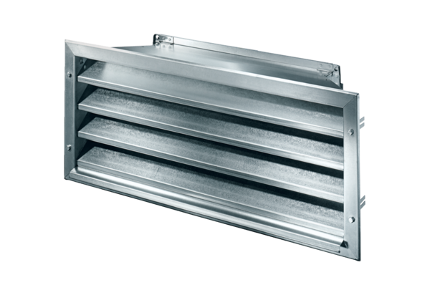External grille LZP-R 31Packing unit: 1 pieceRange: D
Article number: 0151.0384Manufacturer: MAICO

