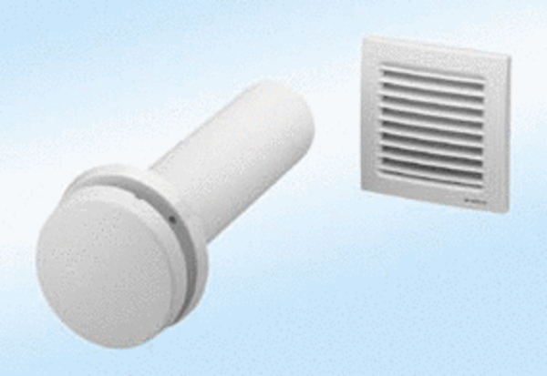Supply air element, uncontrolled ZE8-ITPacking unit: 1 pieceRange:
Article number: 0152.0034Manufacturer: MAICO

