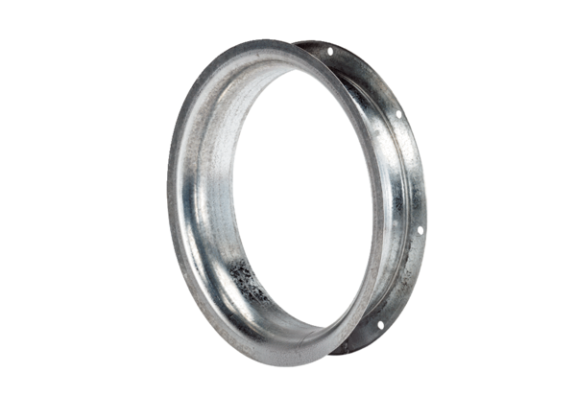Suction nozzle AD 30Packing unit: 1 pieceRange: C
Article number: 0180.0621Manufacturer: MAICO

