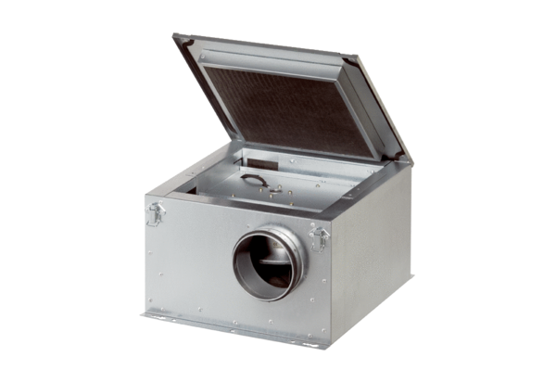Sound-insulated ventilation box ESR 31-2Packing unit: 1 pieceRange: C
Article number: 0080.0614Manufacturer: MAICO

