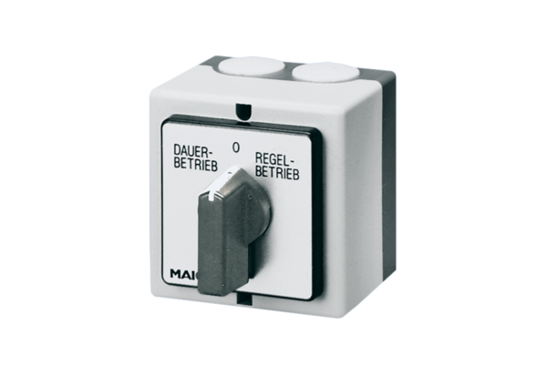Rotary switch DS 10Packing unit: 1 pieceRange: C
Article number: 0157.0410Manufacturer: MAICO

