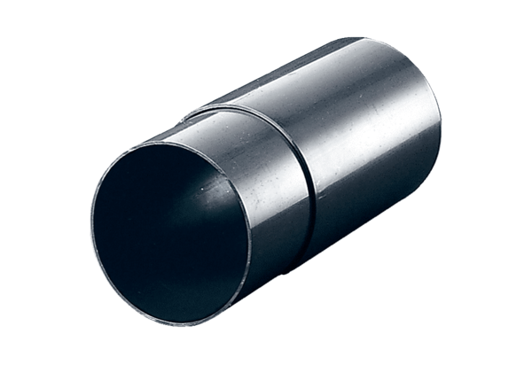Wall sleeve WH 100Packing unit: 1 pieceRange: A
Article number: 0059.1030Manufacturer: MAICO

