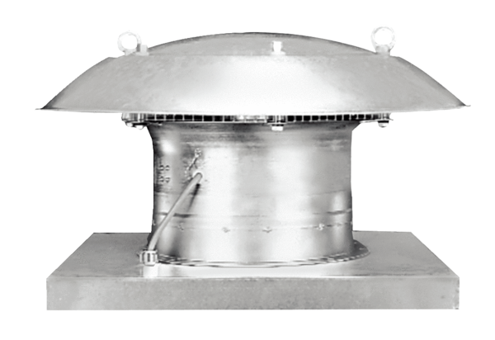Axial roof fan EZD 30/2 BPacking unit: 1 pieceRange: C
Article number: 0087.0205Manufacturer: MAICO

