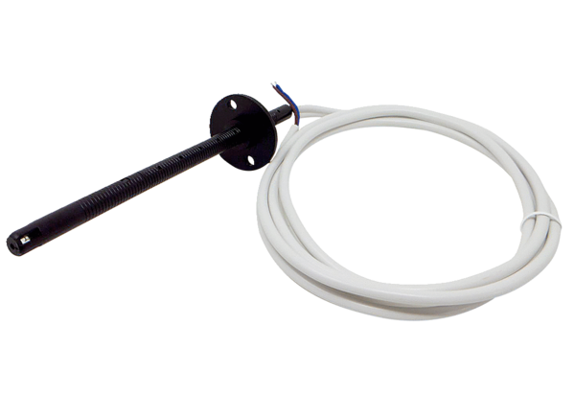Channel sensor FL 30 PPacking unit: 1 pieceRange: D
Article number: 0157.0780Manufacturer: MAICO

