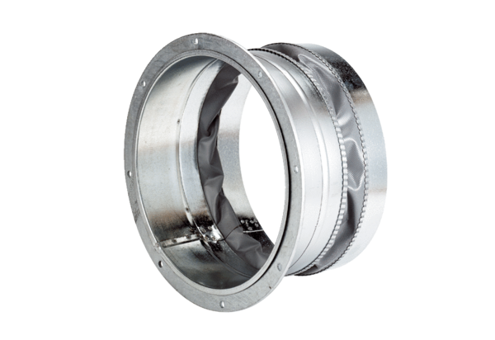Flexible coupling ELA 30Packing unit: 1 pieceRange: C
Article number: 0092.0267Manufacturer: MAICO

