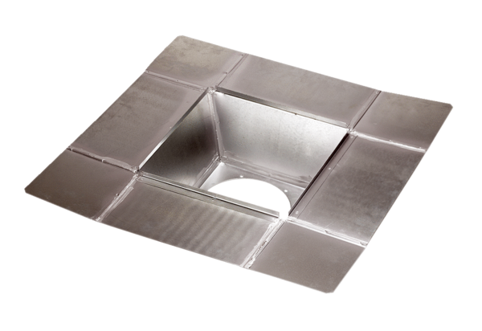Intermediate socket SZ 31Packing unit: 1 pieceRange: C
Article number: 0092.0289Manufacturer: MAICO

